Tools and tips for teaching with LexisLibrary
Tom Laidlaw (LexisNexis)

- Simple searching

Use the ‘Quickfind box’ on the Home page to find cases, legislation and journal articles. LexisLibrary uses ‘word-wheels’ for cases, legislation and a form or precedent to speed up the search just like Google. Search over 500,000 case reports and legislation going back to 1267.

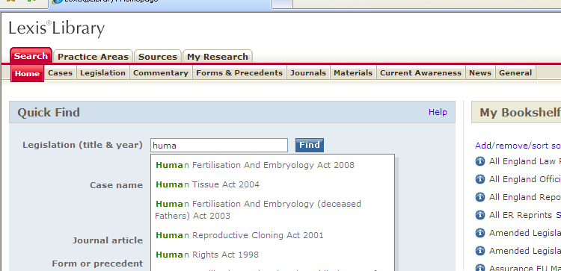

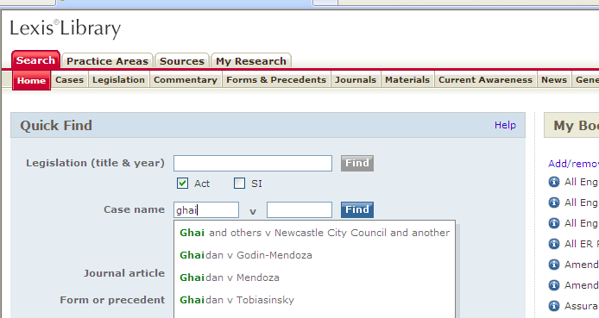

If you want to find out if you have a publication in your subscription, just type the name into the ‘Find a source’ box – particularly useful for international law publications.

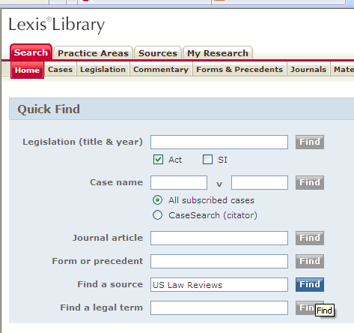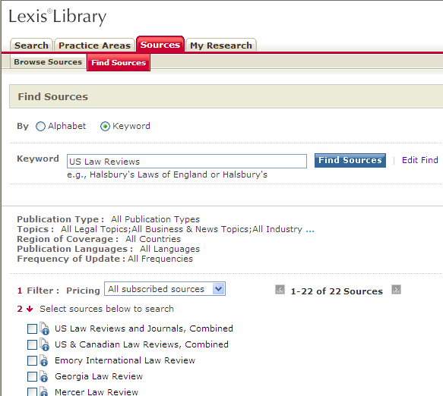
- Supporting directed learning

LexisLibrary has a tool integrated into the main research service called ‘Copy URL’. This tool in the ‘download options’ of a results list allows you to create a permanent link to a case report, piece of legislation or journal article. This link can then be inserted into your VLE so students can always read the information you want them to read.

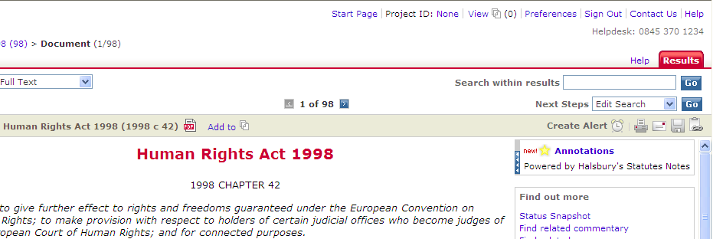

When you click on the icon 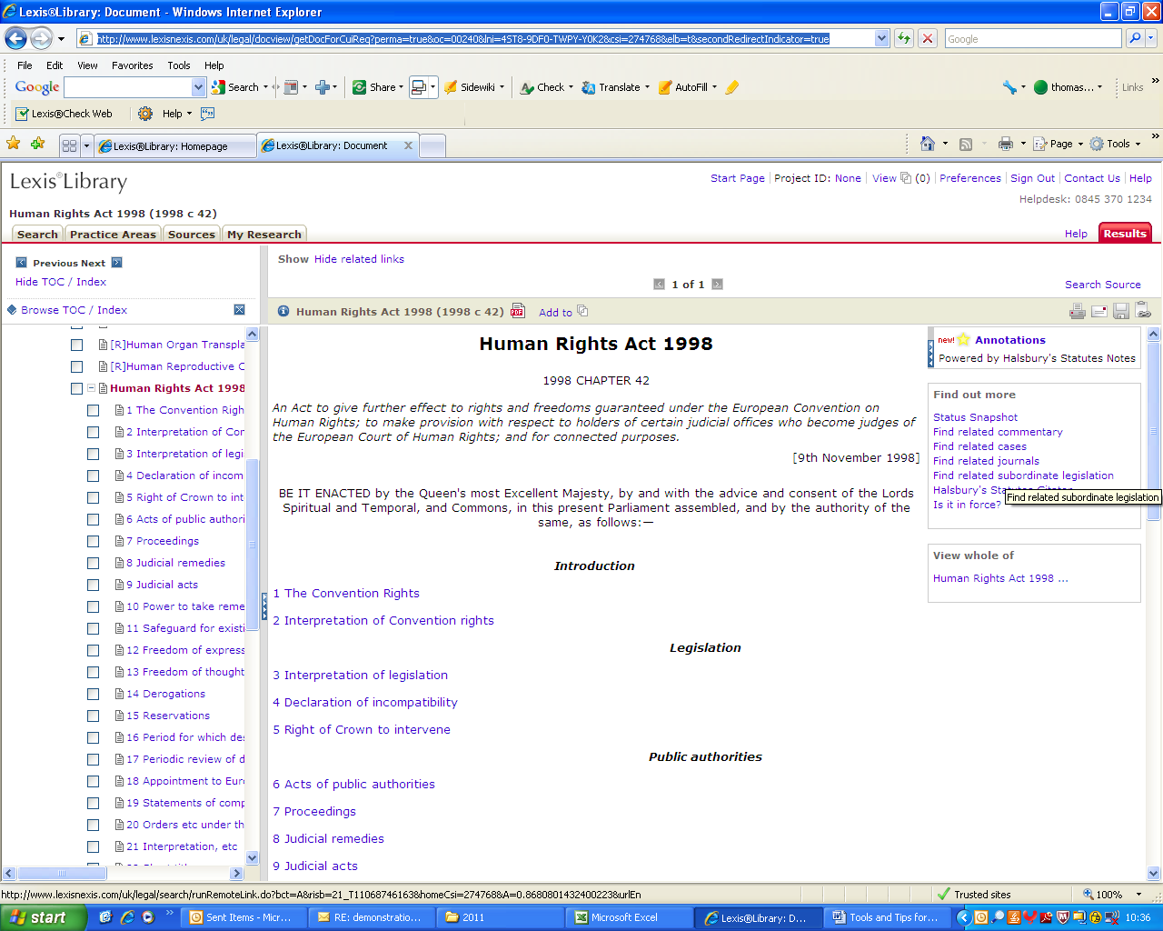 an option box opens that allows you to choose a link to the Act or case as it appears in LexisLibrary or a pdf of the document as it would appear on the printed page. Follow the on-screen instructions.

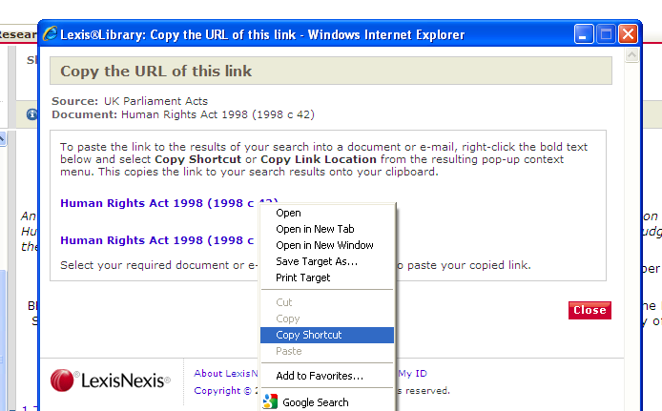

Once you have copied your link, open your Word document and paste in the link into the Address box using Crtl + V as you would any other hypertext link.

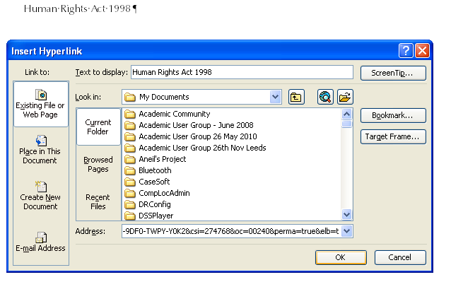

- Making use of Refworks

Refworks is bibliographic software that allows you and your students to download citation information from a journal article or case report from LexisLibrary directly into an article or essay via the Refworks tool.
Once you have found the article you wish to cite, look for the blue ‘book’ icon in the delivery options:
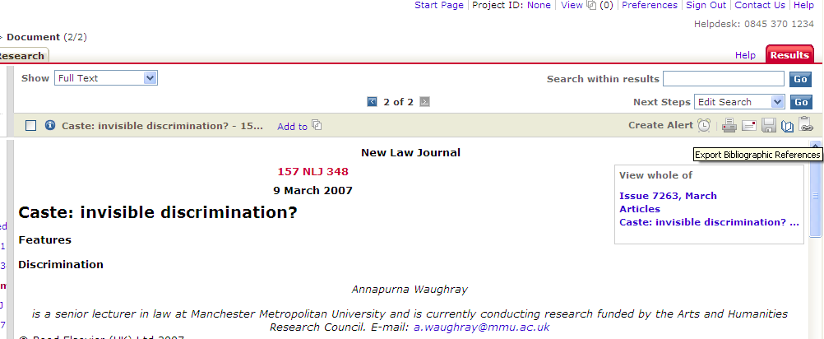
When you click on the icon an option box opens which allows you to export the citation information to Refworks. Follow the on-screen instructions:
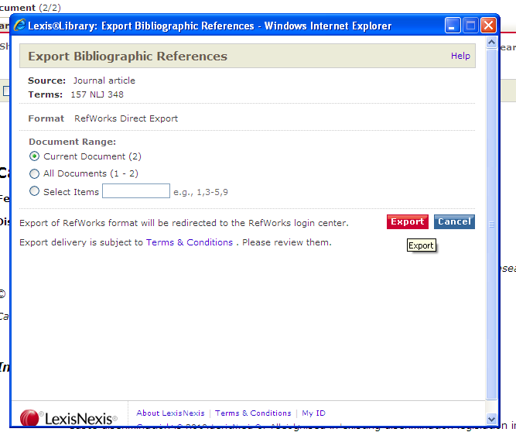
- Tracking changes to legislation and case law
LexisLibrary has brought together the information contained in Halsbury’s ‘Is it in Force’ and Halsbury’s Statutes Citator and delivered it through an option within legislation results called ‘Status Snapshot’.
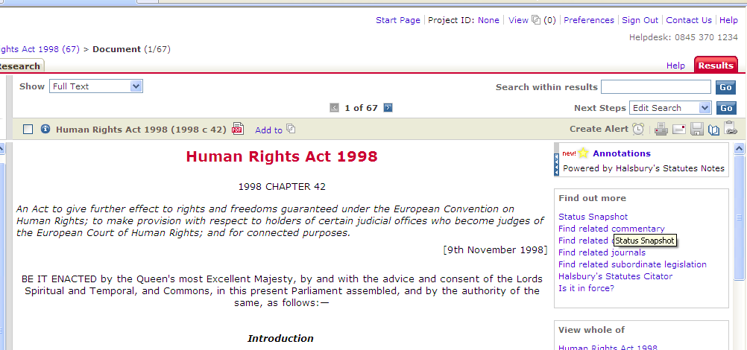
A simple table tells you the commencement information for every section of an Act as well as any and all amending legislation. Easy-to-read symbols also tell you whether the Act or individual section is still in force. All information in the table is linked so you can go straight to the commencement or amending legislation.
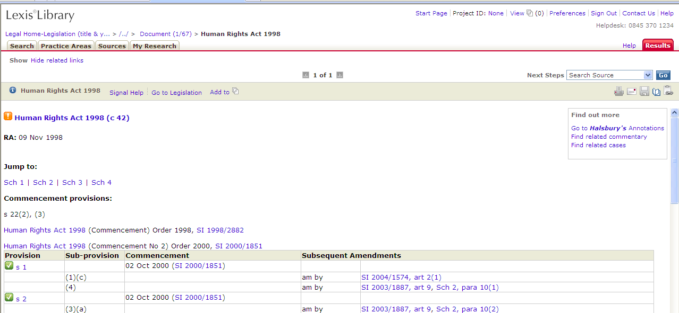
You can also track the progress of Bills through both Houses of Parliament by searching ‘Bill Tracker’. Go to the ‘Current Awareness’ tab and choose ‘Bill Tracker’ from the drop down menu, then add some search terms.
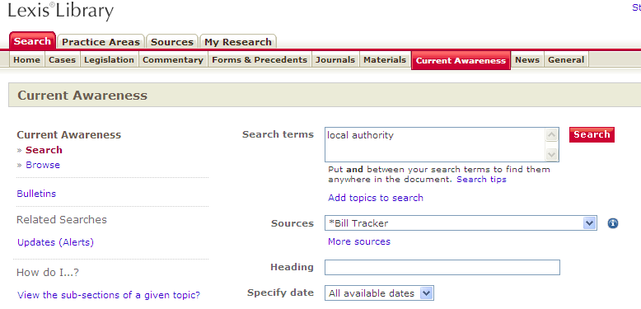

Casesearch in LexisLibrary delivers citation information for over 200,000 cases. East-to-read symbols tell you whether the case has been overruled or is still ‘good law’. To get to the Casesearch citation document, run a search as suggested at the top of this document. In your results list, look out for the ‘Casesearch’ source and click on the case name.
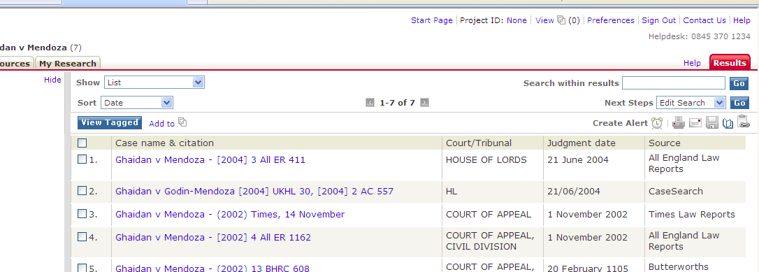
The Casesearch document provides you with a complete list of citations for the case and links to the various reports available in the LexisLibrary database. It also tells you the case history – all of the cases referring to the case and all of the cases considered by that case that are mentioned in the judgment and a digest and catchwords written by a member of the All England court reporting team.
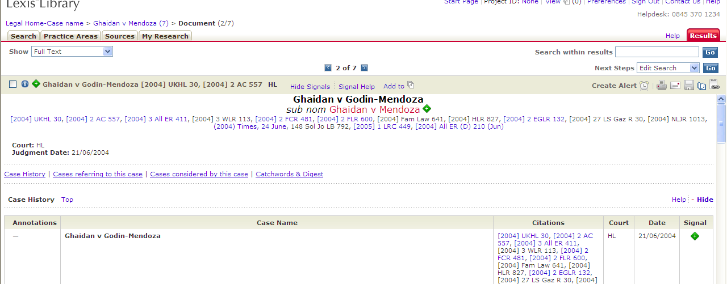
You can also track the progress of appeals using the Appeal Tracker function in Casesearch. Look out for the Appeal Tracker button in a Casesearch result. This information tells you were the case has reached in the appeals process and LexisLibrary tracks the appeals of all ‘starred’ cases from the All England Reporter. Starred cases (indicated with the symbol * before the case name) indicate that a case will be considered for inclusion in the All England Law Reports and/or one of our Specialist Reports series.
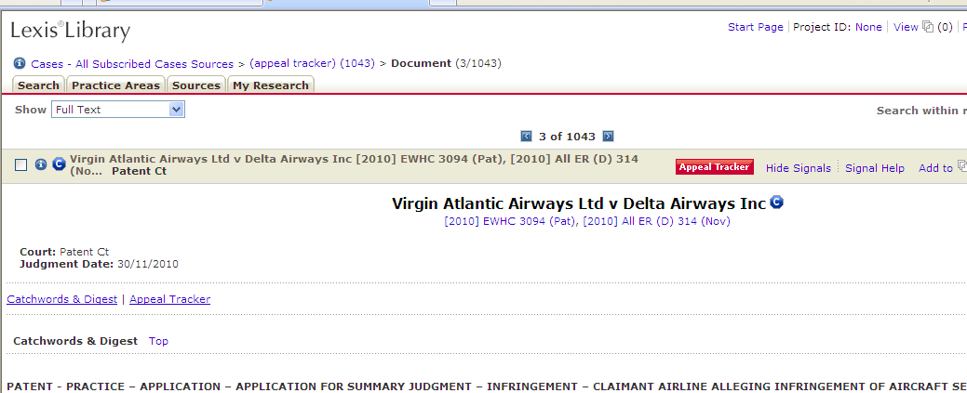
- Setting up alerts
As teachers and researchers you are always trying to keep abreast of changes to the law to ensure teaching materials and research output is accurate. There are a number of ways to keep up to date using LexisLibrary.
  - RSS Feeds
The simplest way to be alerted to changes is to subscribe to RSS feeds on LexisLibrary. Look out for the RSS icon 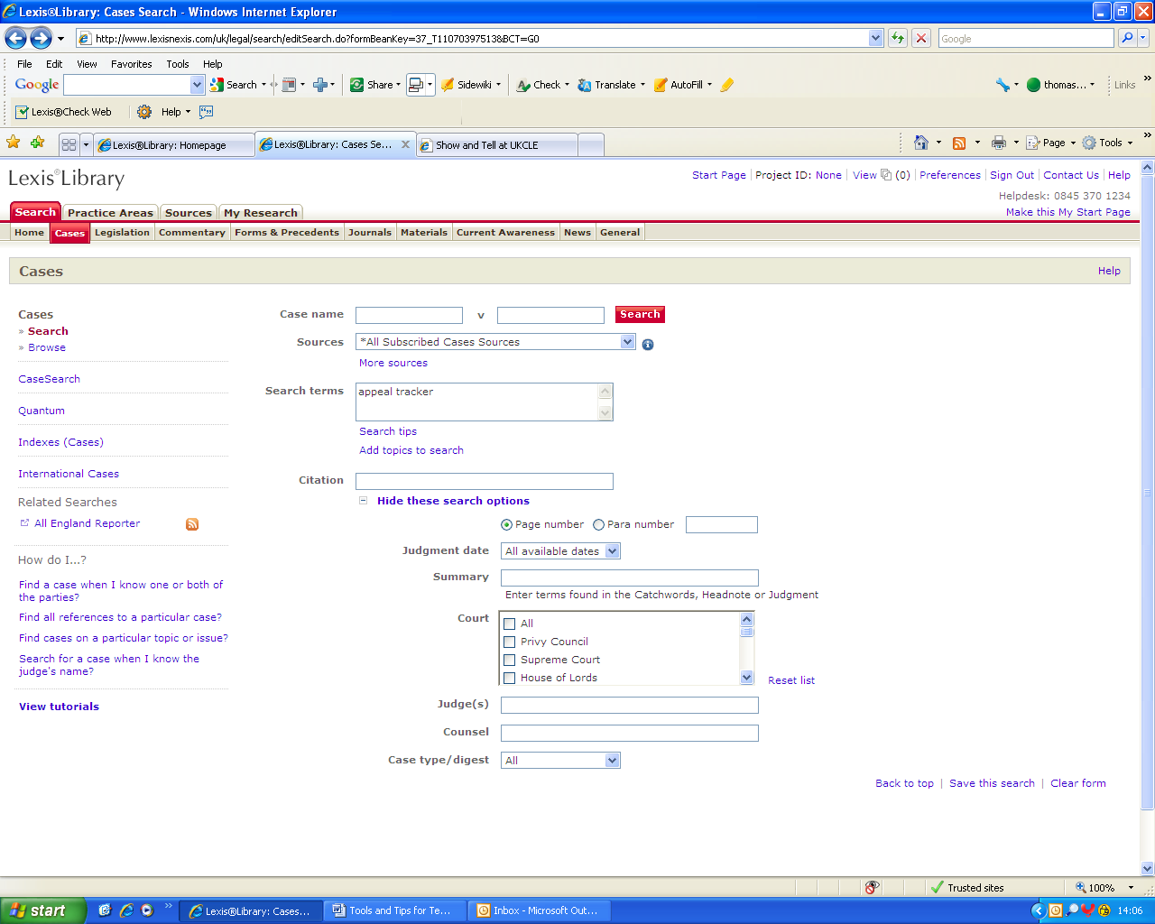. It can be found next to the All England Reporter link in the Cases search screen or on the various Practice Area pages.
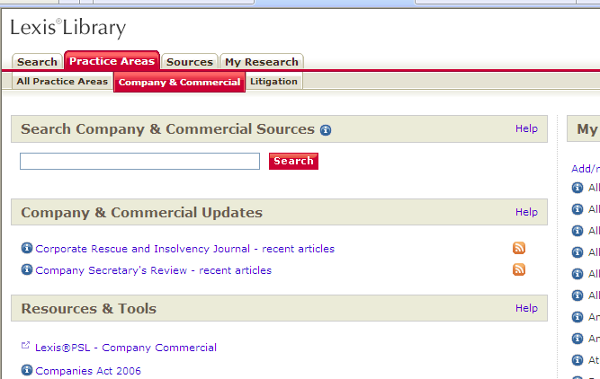
  - Alerts via ‘My Research’
Click on the ‘My Research’ tab and you will be taken to a set up screen where you can create your own focussed alerts using an ‘’Update Wizard’.
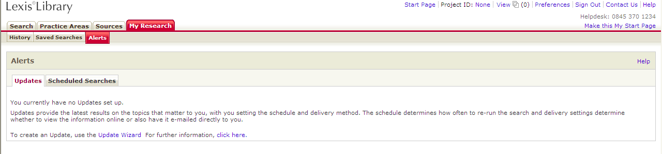
Using the wizard you can set up LexisLibrary to regularly search different current awareness publications e.g. UK Journals Index for specific legal concepts. You can set the frequency of the search and also where the results are delivered to e.g. your personal email in-box.
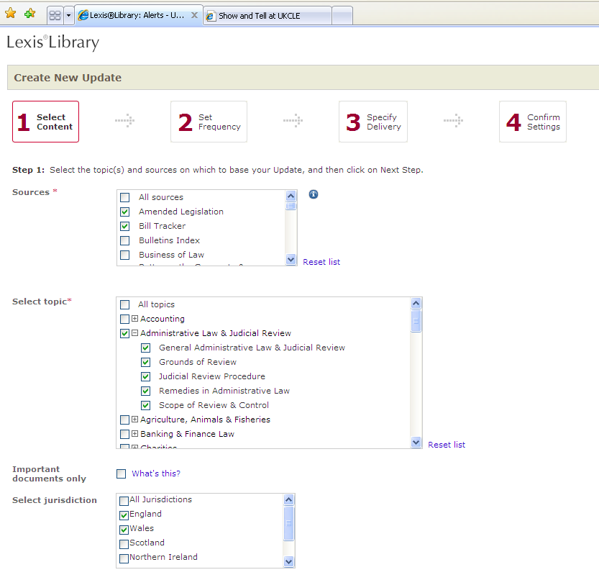
- Making Mooting research easier
Students are often set problems that contain legal concepts that they are unfamiliar with, but which are identified in the moot problem. Possibly the simplest way to look for information on a legal concept is to search using ‘Find a legal term’ in Quickfind on the Home page.
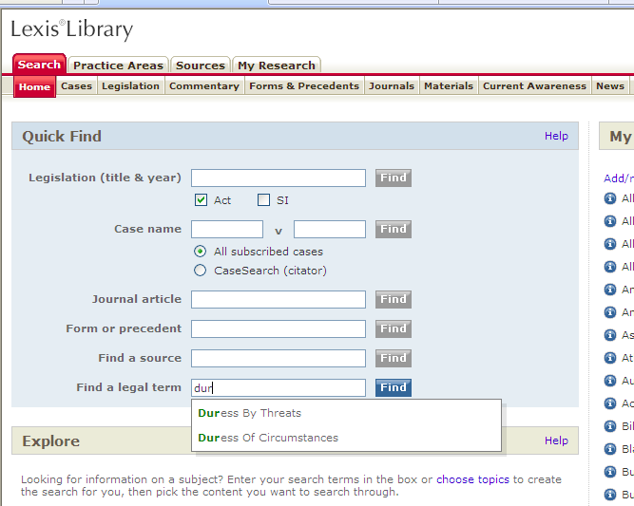
Searching using a legal term will send the student to an index page that sets out the correct legal definition and provides links to key cases, legislation and supporting narrative texts that will lead the student deeper into the subject. Definitions come from ‘Words and Phrases Legally Defined’.
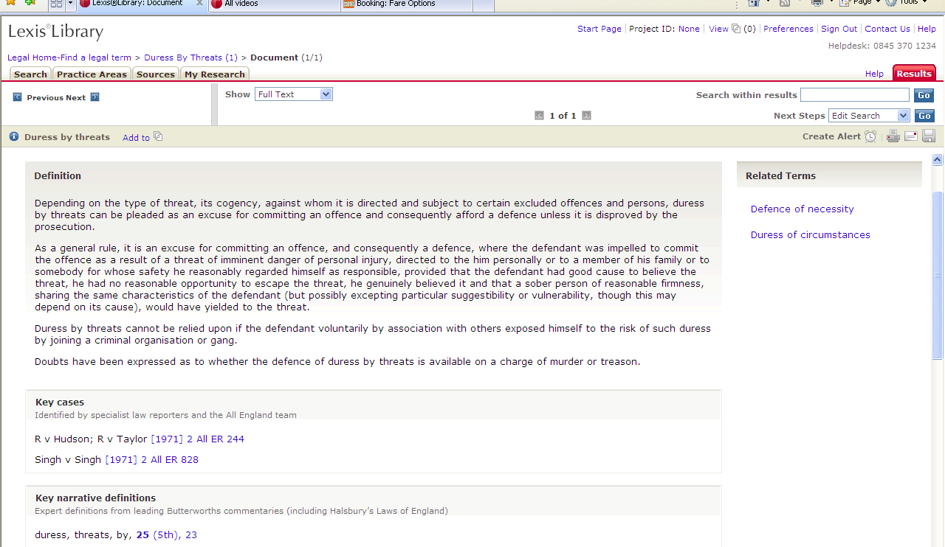
Once students have found their supporting case law and legislation, they can use LexisLibrary to create their bundles by downloading case reports and legislation as pdf documents that look like the printed page.
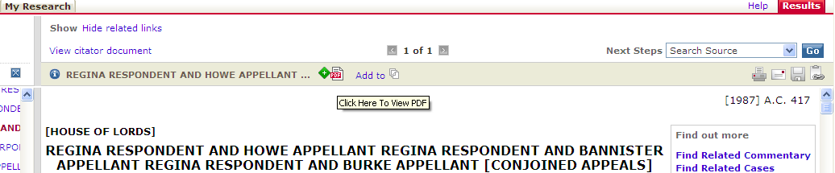
- Where are my International Law materials?
LexisLibrary is structured in such a way as to identify legal information by content type e.g. cases, journals etc. For this reason, access to international cases, legislation and journals is via links on the left hand side of the content-specific pages on LexisLibrary.
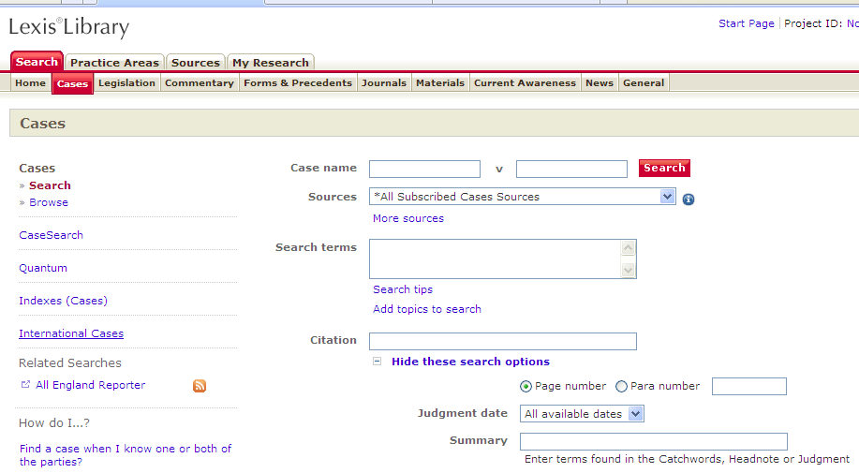
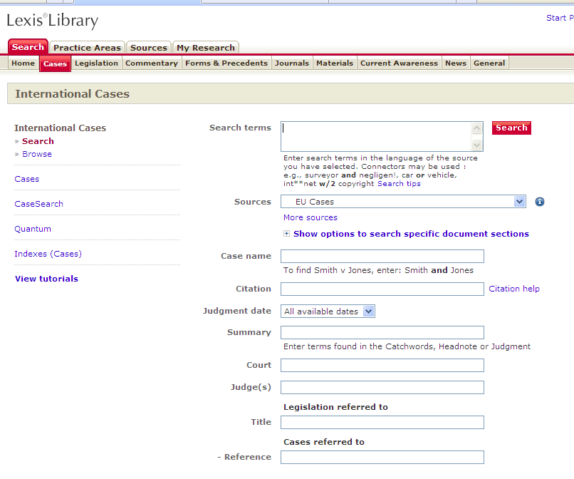
In a standard Academic subscription to LexisLibrary, you will have access to thousands of publications including:
- All EU Cases and EU Legislation from EUR-Lex.
- All US State and Federal case law.
- All US State and Federal Code
- American Jurisprudence, 2nd edn.
- Over 700 US law reviews including the Harvard and Yale Law Reviews.
- Halsbury’s Laws of Hong Kong
- The Journal of Contract Law (Australia).

